**OS ASSIGNMENT 1**

**21K-3278-D Sohaib Sarosh Shamsi**

1: First we will download Kernel from kernel.org i did 4.19.272 Version [tarball] format. After it is downloaded extract the folder and in the extracted folder will make a new folder named 'hello'.

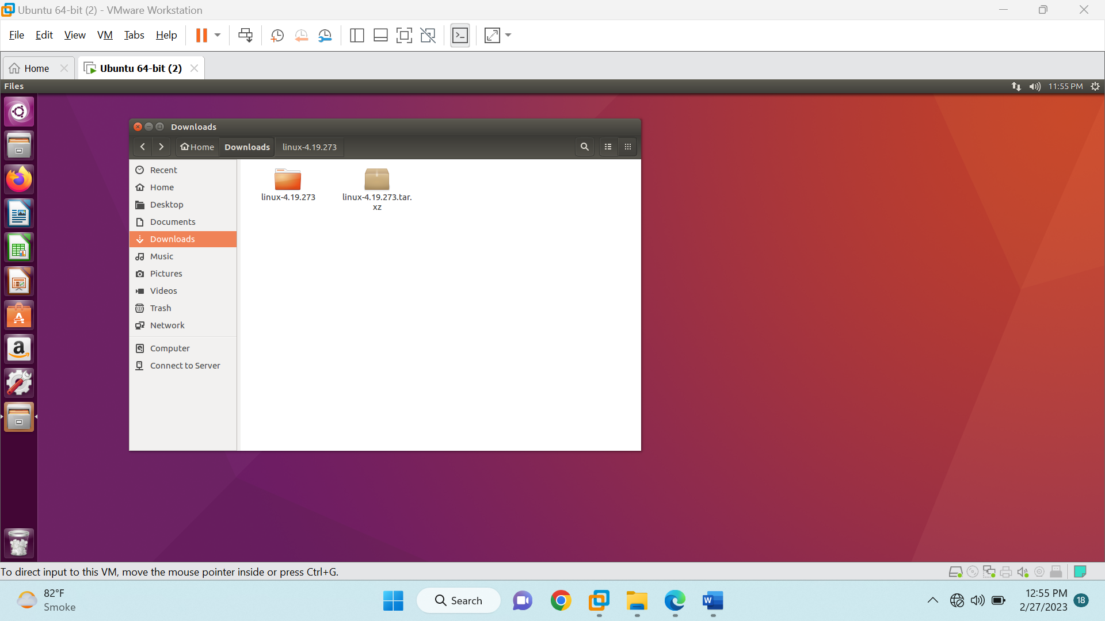

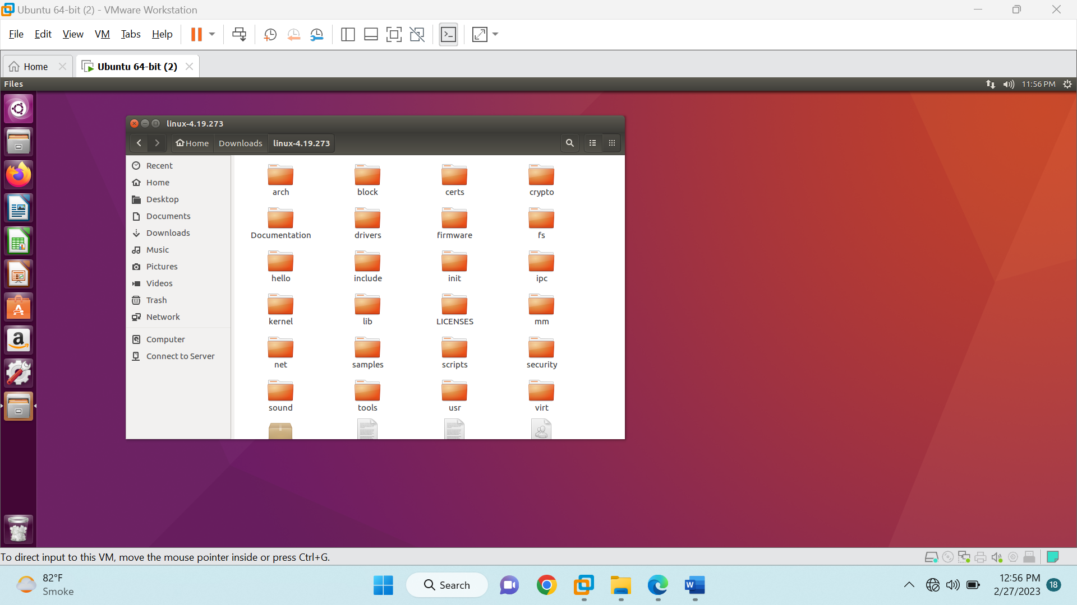 2: In that folder, Run a terminal, we'll make two files 'hello.c' (our task to run) and Makefile via terminal commands 'gedit hello.c' and gedit Makefile respectively

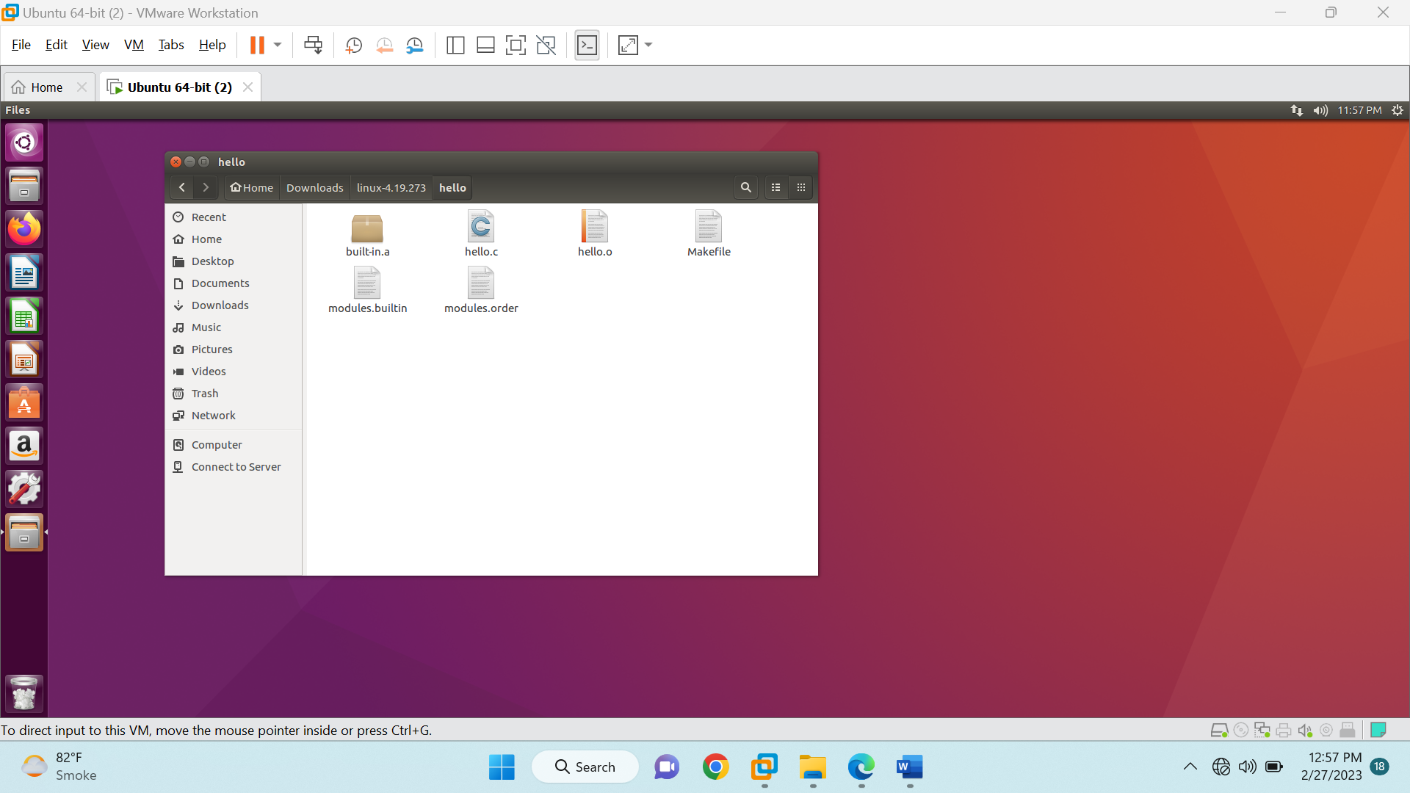 3: In hello.c write this code #include <linux/kernel.h> asmlinkage long sys_hello(void) { printk("Hello world\n"); return 0; }

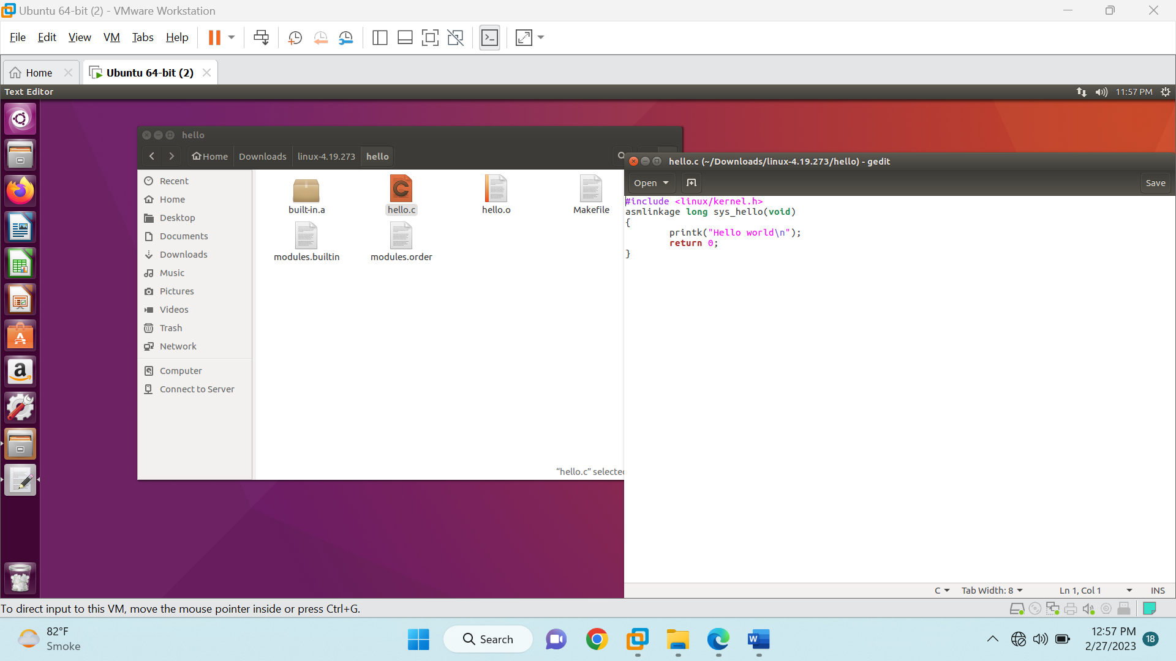

4: In Makefile add this obj-y := hello.o

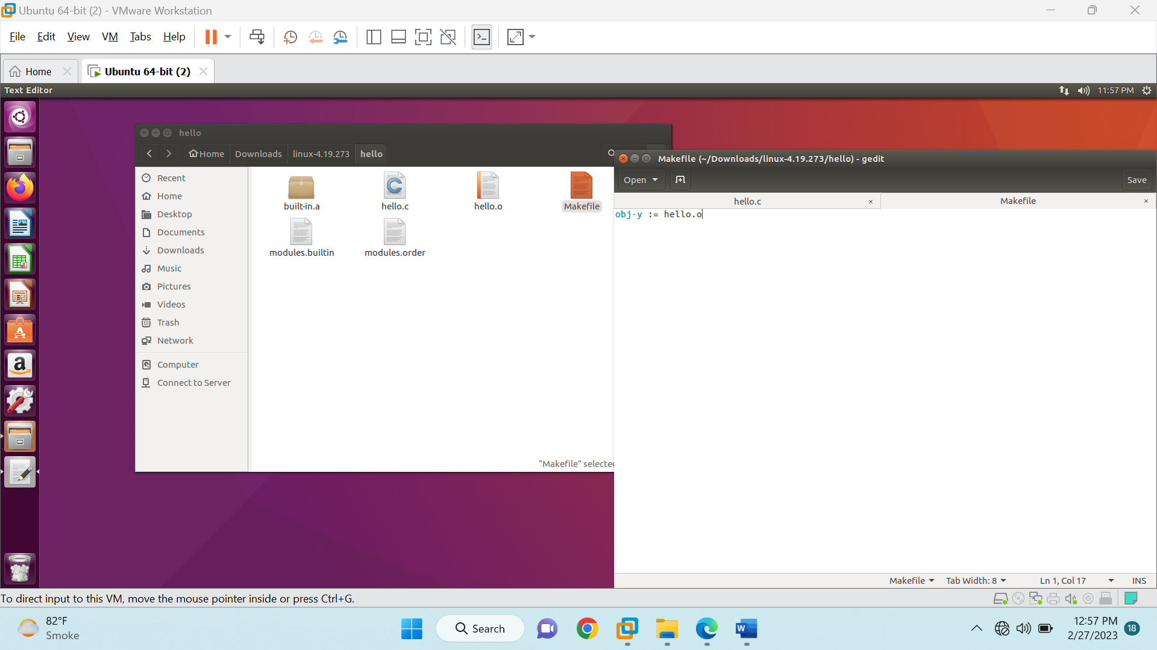

5: We have to add the system call entry into the syscall_64.tbl file which keeps the name of all the system. For doing this we will open that file by running command in terminal which will open a file

arch/x86/entry/syscalls/syscall_64.tbl

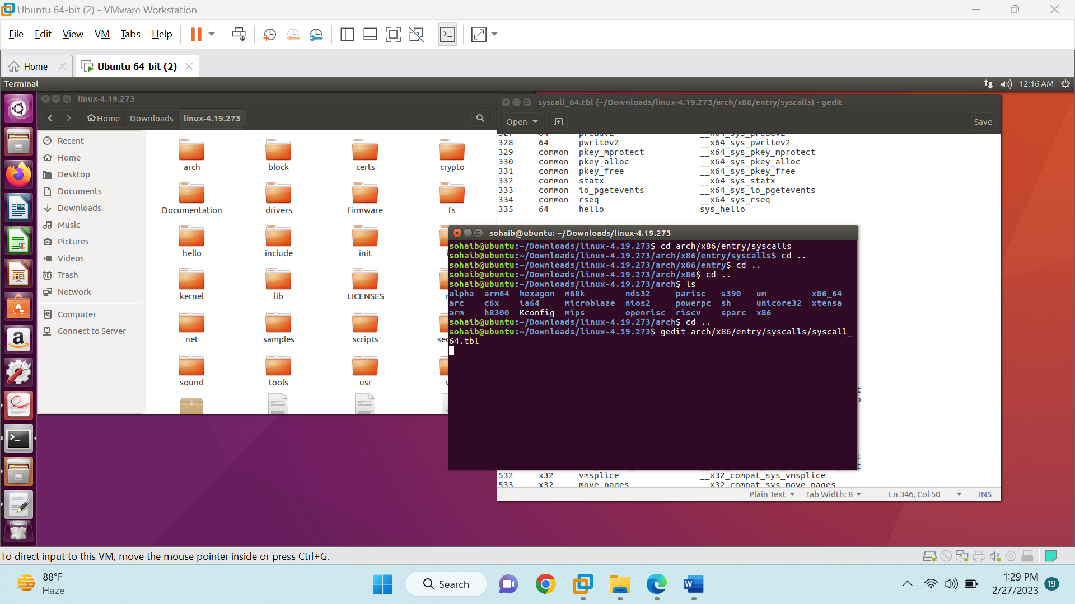

6: In the syscall_64.tbl file scroll down to line [334], in the next line put this line (which will be line 335), then save the file.

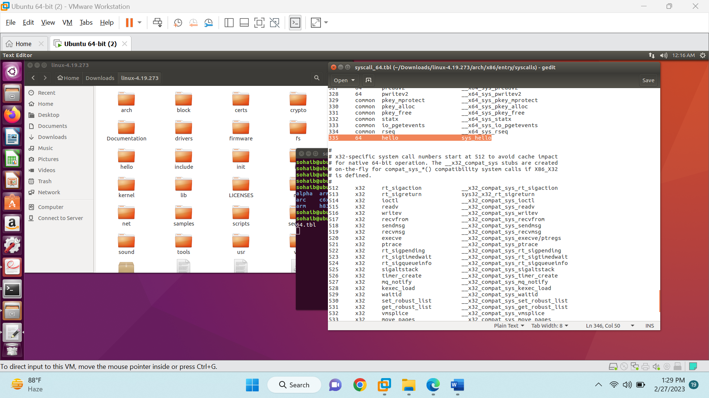

7: Now we have to add the prototype of our system call in the system’s header file. In kernel folder “/include/linux/syscalls.h” we have to add the prototype of our system call function in this file.

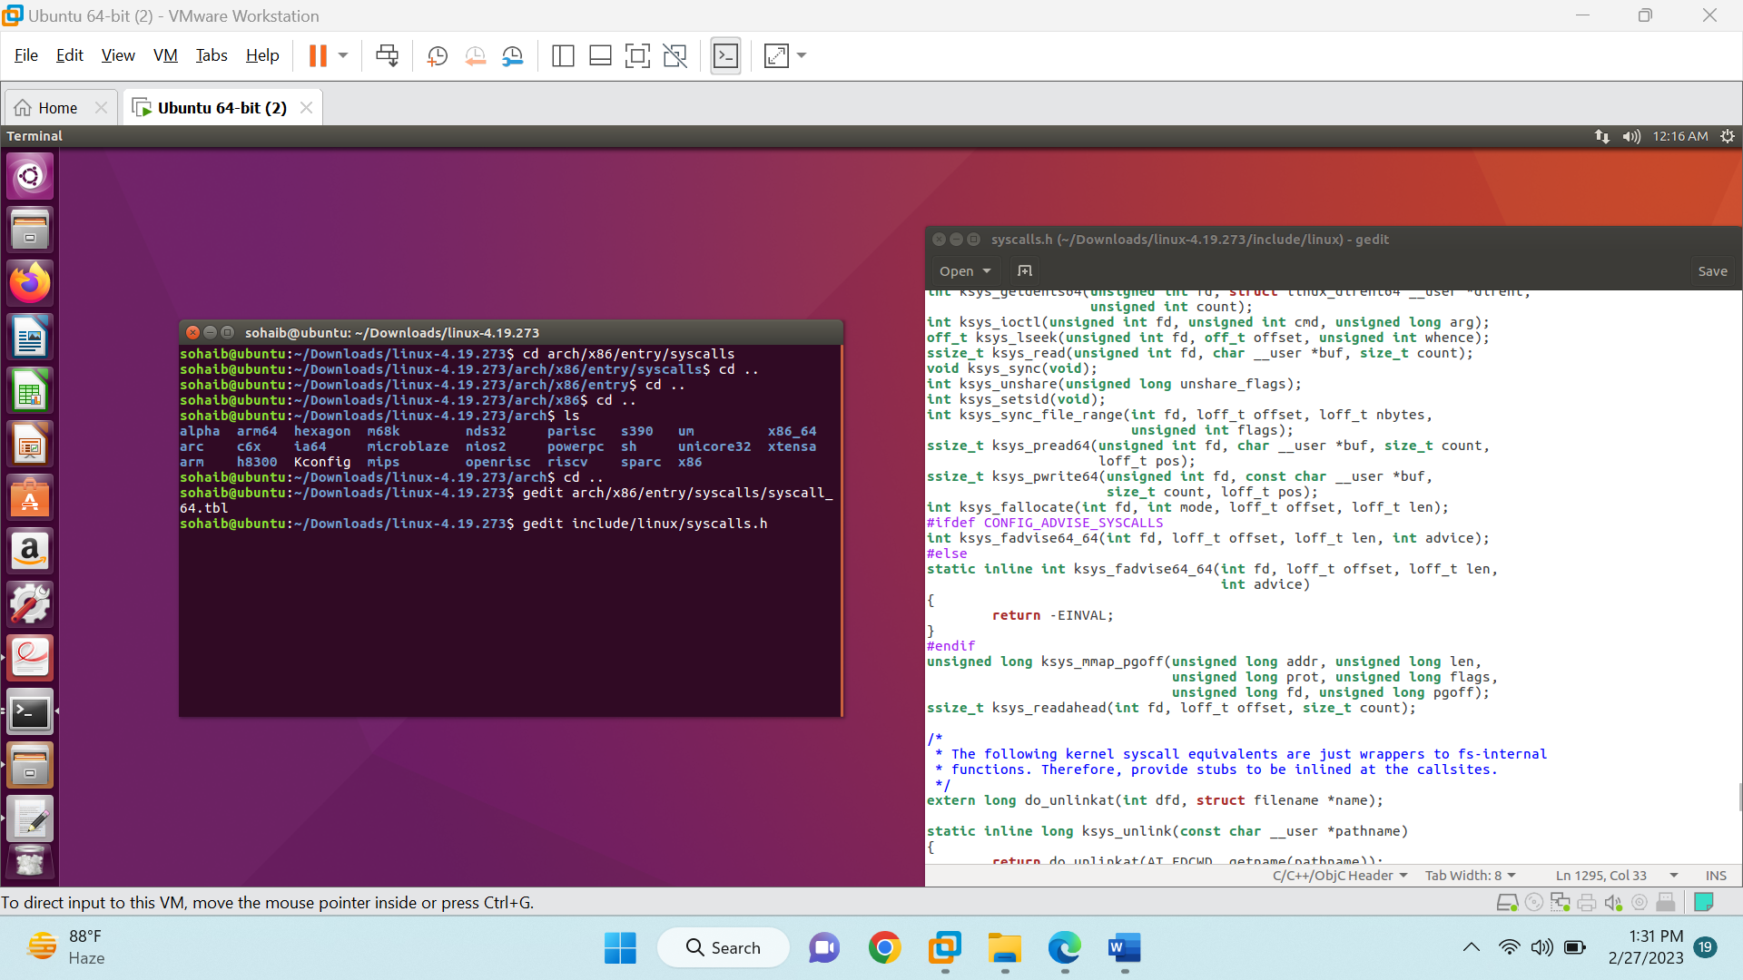

8: In this file we just have to add our function call in the system file by simply typing in the function name in the end, save it.

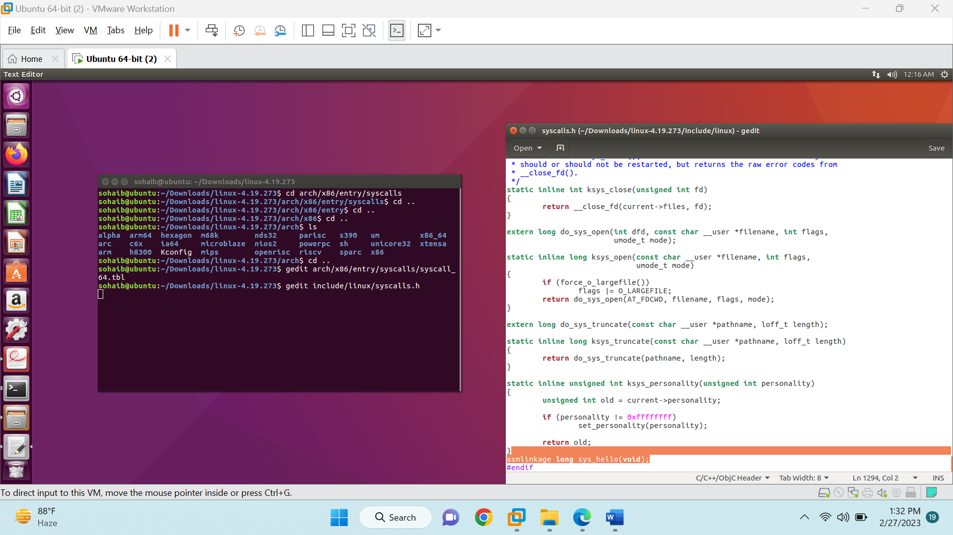

9: Open Makefile and in Extraversion put the value equal to the roll number

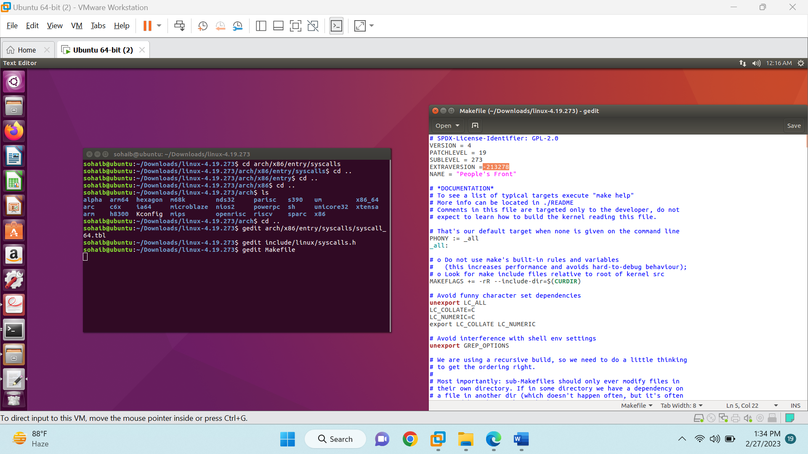

10: Press CTRL+F in the same file and search for "core-y", navigate to second instance and in the end of the line put " hello/"

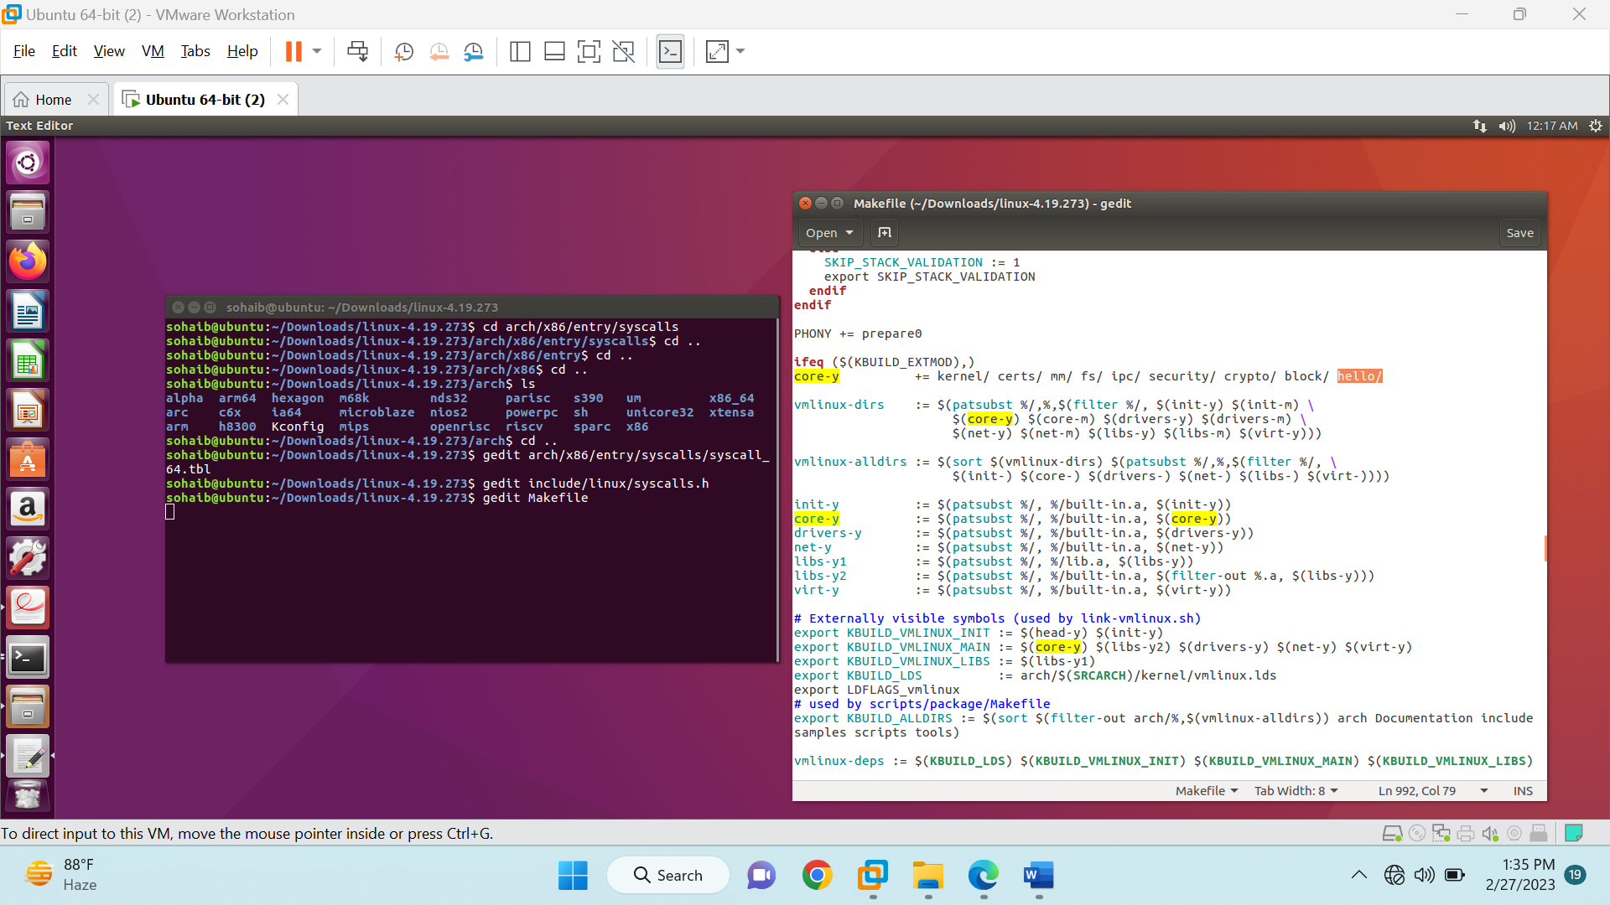

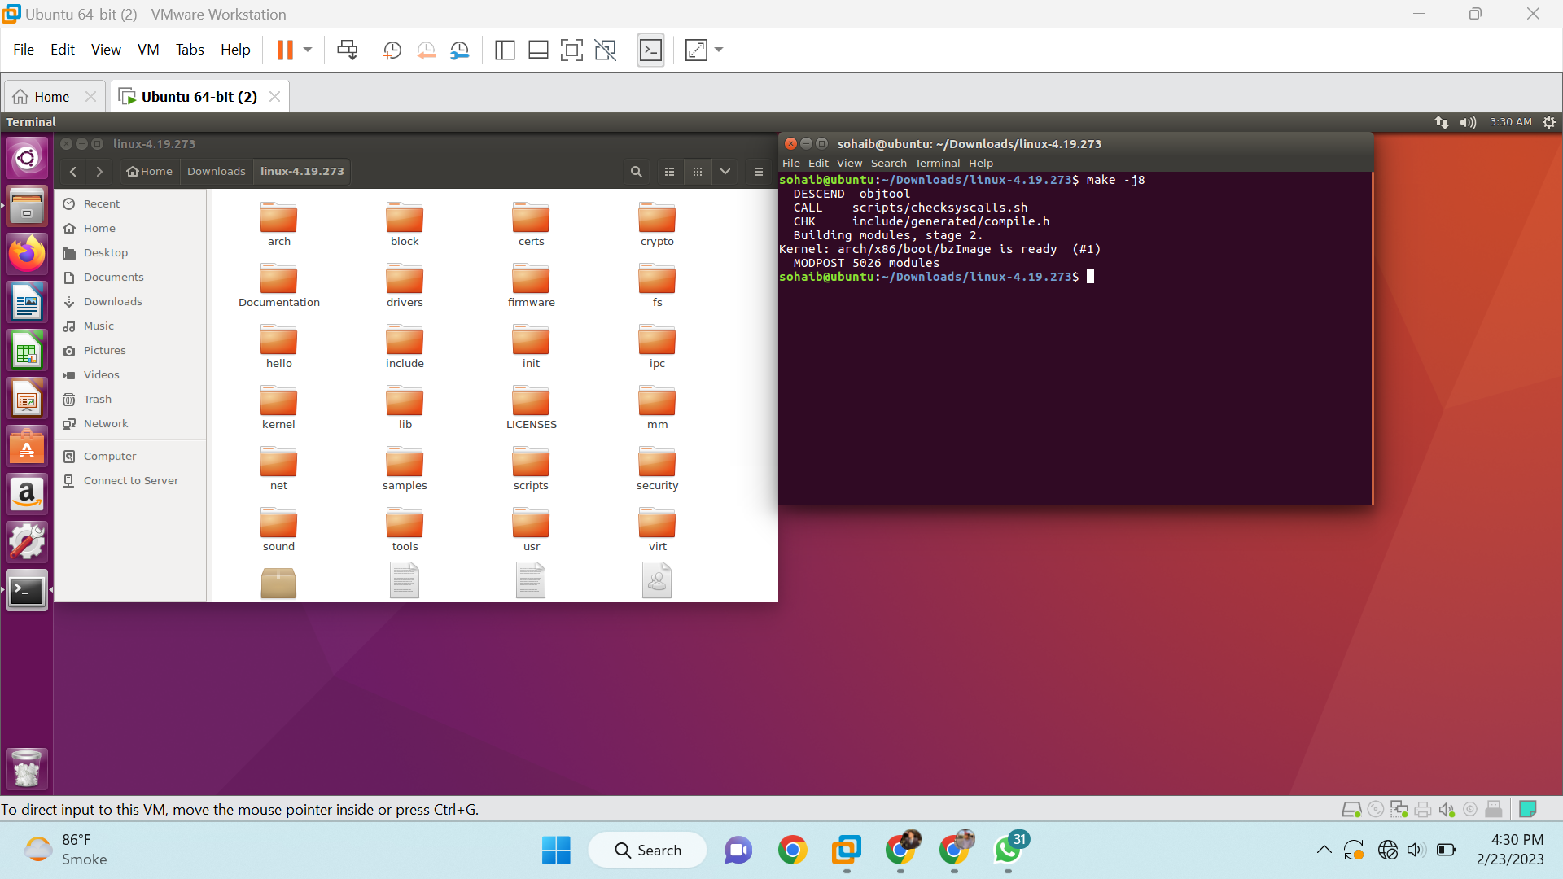

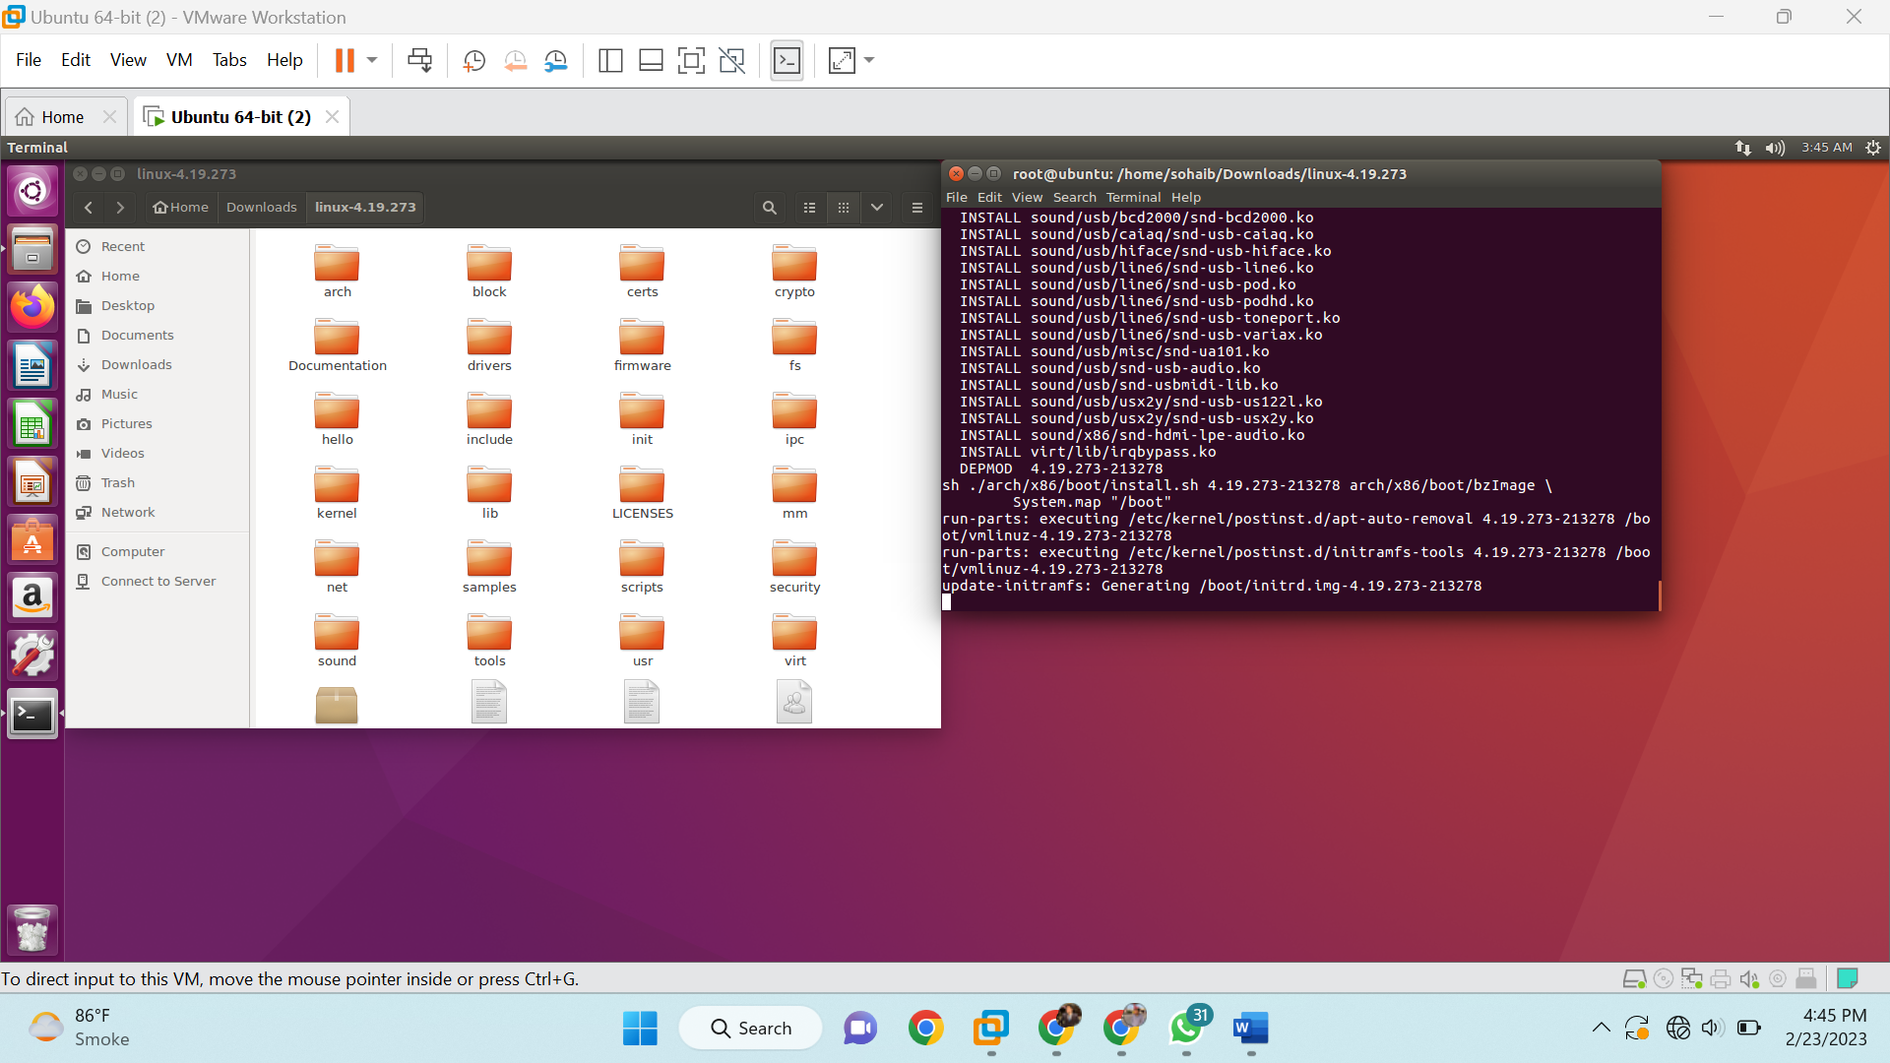

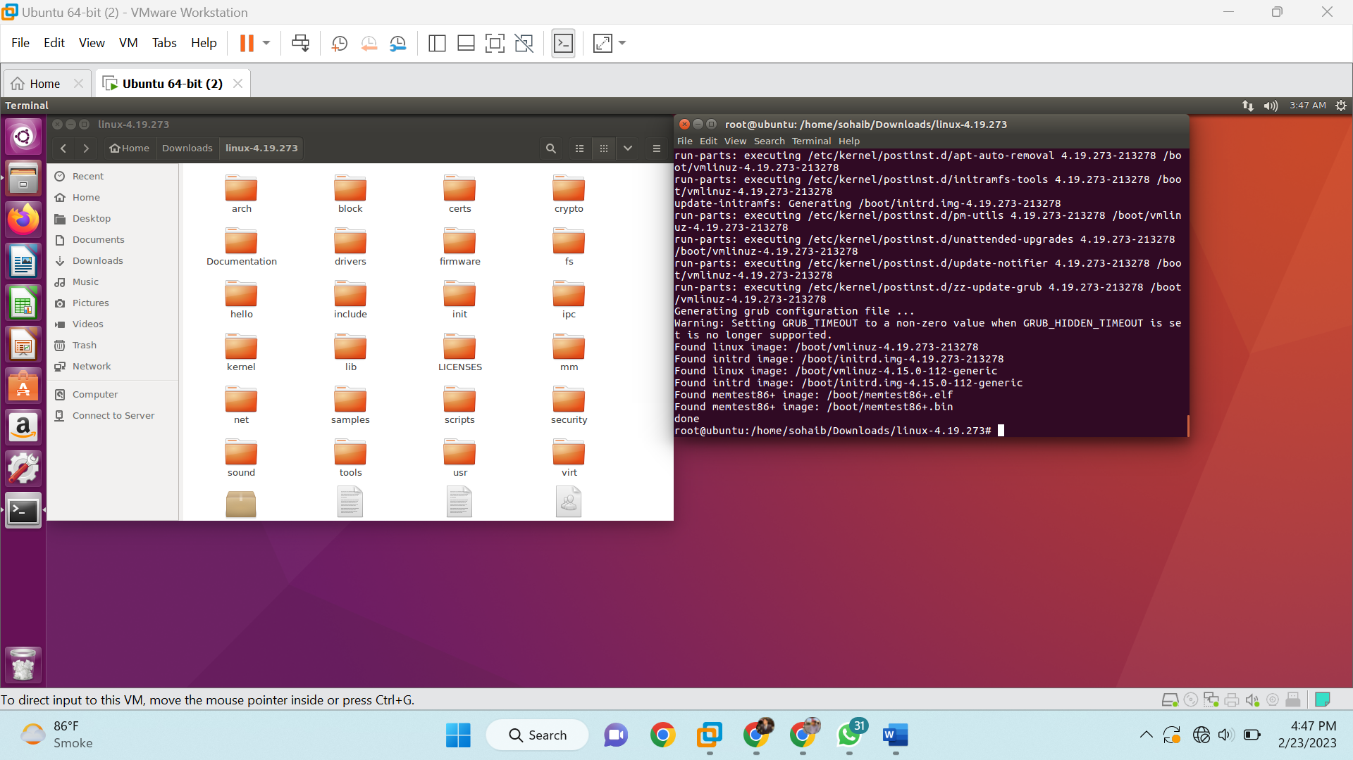

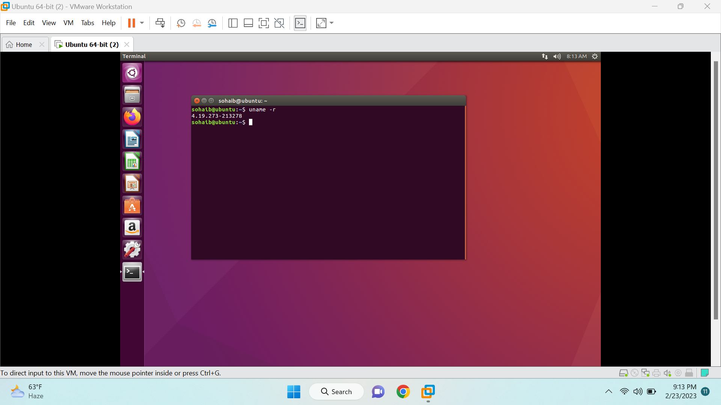

213278 is my roll number.

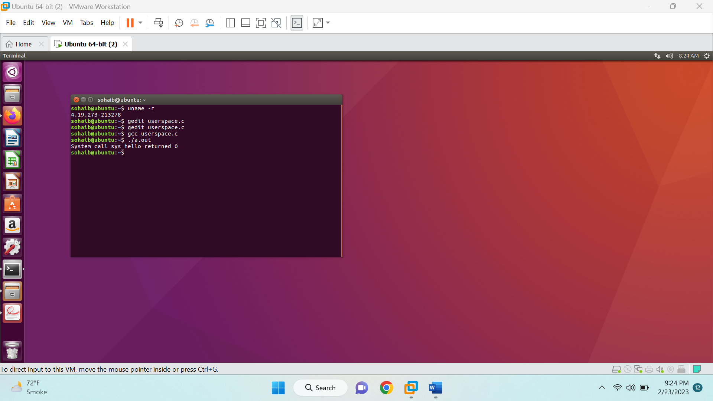

dmesg command

